**GRAVEL ROAD WORKS - MATERIAL SCHEDULE**

**MATERIAL SCHEDULE:**

| **Item** | **Payment Item** | **Description** | **Unit** | **Rate (R)** |
| --- | --- | --- | --- | --- |
| 1 | 5.20.18 | Blading material into windrow | m² | 800.00 |
| 2 | 5.20.7 | Compaction of in-situ subgrade to 93% Mod AASHTO | m² | 150.00 |
| 3 | 5.11.13 | Importation of G7 gravel from commercial source | m³ | 500.00 |
| 4 | 5.24.15 | Compaction of G7 material to 95% Mod AASHTO (150mm thick) | m² | 250.00 |

**CONSTRUCTION REQUIREMENTS:**

* Road width: 6.0m total including 500mm shoulders on each side
* Existing material to be bladed into windrows before subgrade preparation
* Subgrade to be scarified, moistened and compacted to 93% Mod AASHTO
* G7 gravel to be imported from approved commercial source
* G7 layer to be placed in maximum 75mm lifts
* Each lift to be compacted to 95% Mod AASHTO density
* Final G7 layer thickness: 150mm after compaction
* Maintain 4% crossfall from centreline to both edges
* Compaction tests to be carried out at frequencies specified
* Submit material test certificates for G7 gravel before placement
* Protect existing services during construction
* Implement traffic management plan during execution

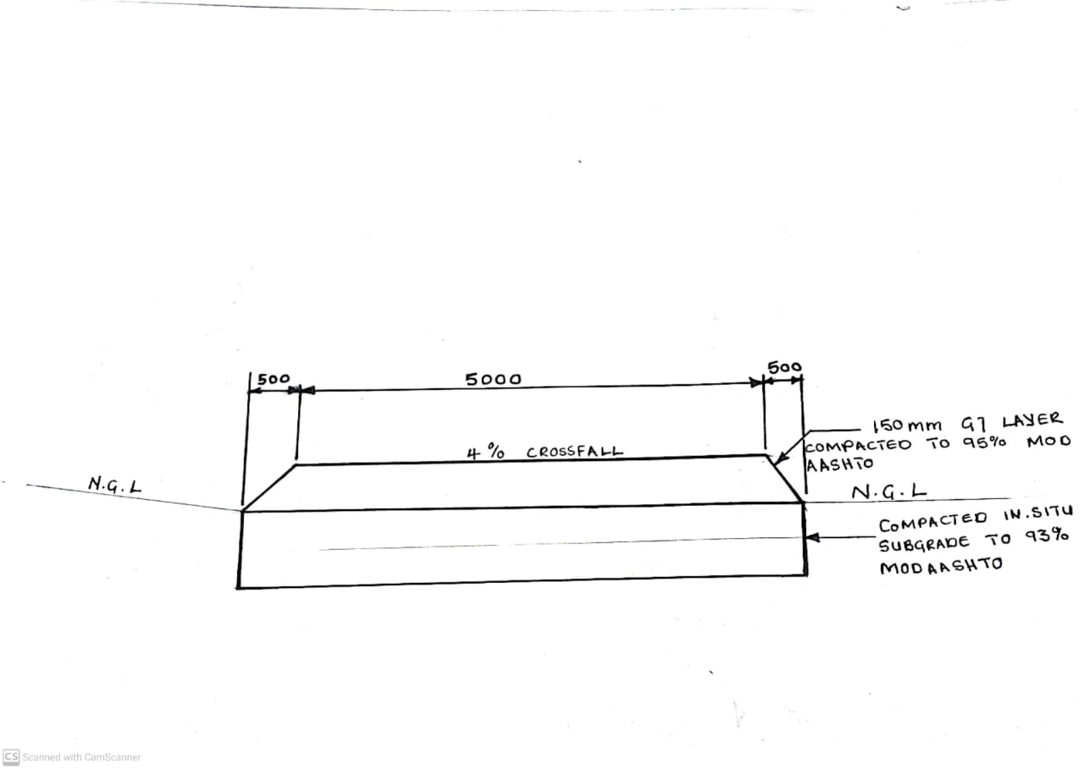

Figure 1: Road layer details sketch